Name : Abdul Rehman Section :B

Course : CCN Roll No : CT-22052

---------------------------------------------------------------------------------------------------------------------  
  
**Lab # 5:**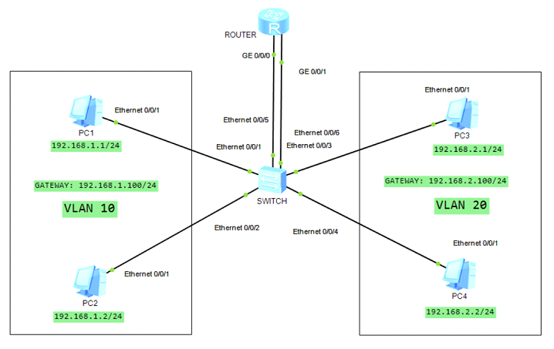

**SWITCH CONFIGURATION:**

#

vlan batch 10 20

#

interface Ethernet0/0/1

port link-type access

port default vlan 10

#

interface Ethernet0/0/2

port link-type access

port default vlan 10

#

interface Ethernet0/0/3

port link-type access

port default vlan 20

#

interface Ethernet0/0/4

port link-type access

port default vlan 20

#

interface Ethernet0/0/5

port link-type access

port default vlan 10

#

interface Ethernet0/0/6

port link-type access

port default vlan 20

#

**ROUTER CONFIGURATION:**

#

interface GigabitEthernet0/0/0

ip address 192.168.1.100 255.255.255.0

#

interface GigabitEthernet0/0/1

ip address 192.168.2.100 255.255.255.0

#

  
  
  
